Name: Hitendra Sisodia

Sap Id: 500091910

**Aim:**

Study of basic network command and Network configuration commands.

**Apparatus (Software):**

Command Prompt

**Theory:**

Cisco Packet Tracer is a network simulation program that allows students to experiment with network behaviour and ask “what if” questions. As an integral part of the Networking Academy comprehensive learning experience, Packet Tracer provides simulation, visualization, authoring, assessment, and collaboration capabilities and facilitates the teaching and learning of complex technology concepts.

**Procedure:**

**Basic Networking Commands and Configuration Commands**

**1. ipconfig:** Displays all current TCP/IP network configuration values and refreshes Dynamic Host Configuration Protocol (DHCP) and Domain Name System (DNS) settings. Used without parameters, **ipconfig** displays Internet Protocol version 4 (IPv4) and IPv6 addresses, subnet mask, and default gateway for all adapters.

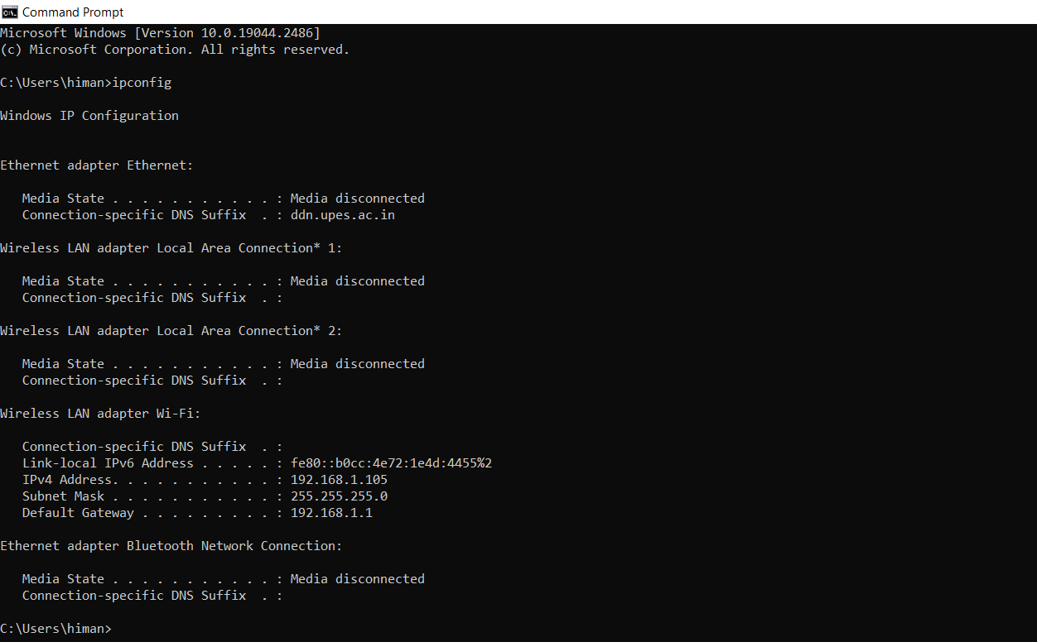

**2. ipconfig/all:** Displays the full TCP/IP configuration for all adapters. Adapters can represent physical interfaces, such as installed network adapters, or logical interfaces, such as dial-up connections.

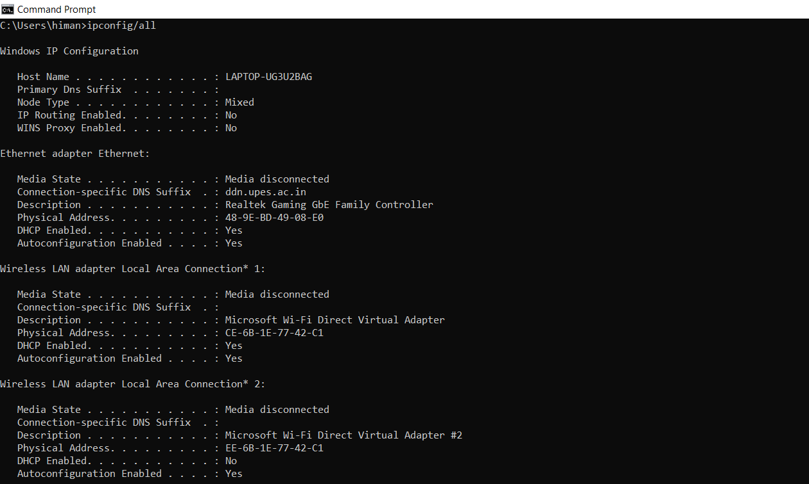

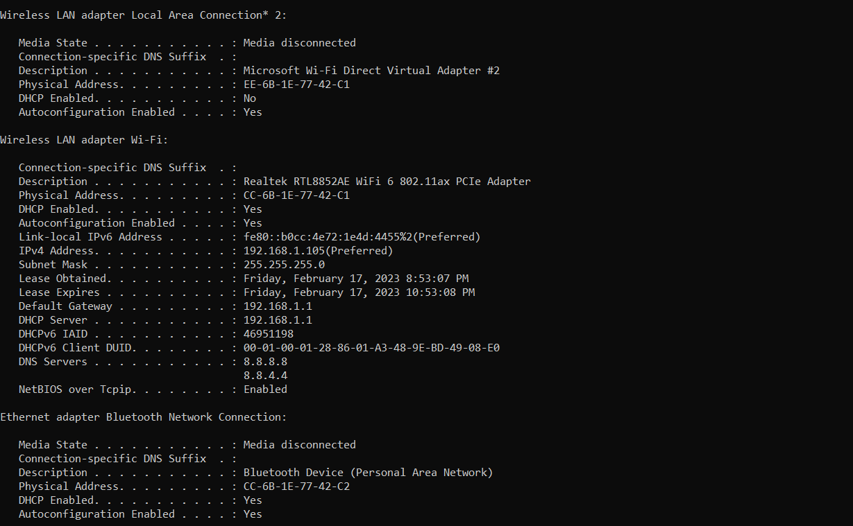

**3. nslookup:** nslookup is an abbreviation of name server lookup and **allows you to query your DNS service**. The tool is typically used to obtain a domain name via your command line interface (CLI), receive IP address mapping details, and lookup DNS records.

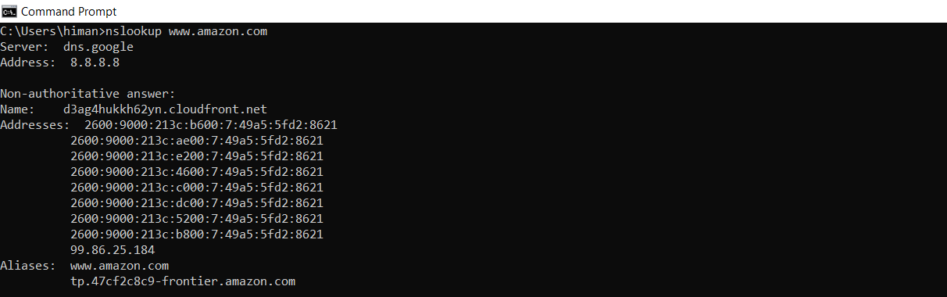

**4. ping:** ping is the primary TCP/IP command used to troubleshoot connectivity, reachability, and name resolution. Used without parameters, this command displays Help content. You can also use this command to test both the computer name and the IP address of the computer.

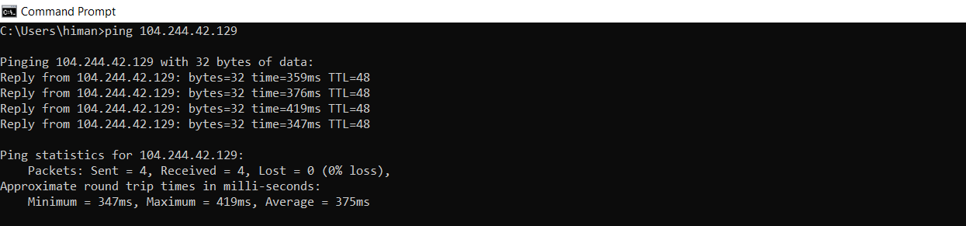

**5. tracert:** TRACERT (Trace Route), a command-line utility that you can use to trace the path that an Internet Protocol (IP) packet takes to its destination.

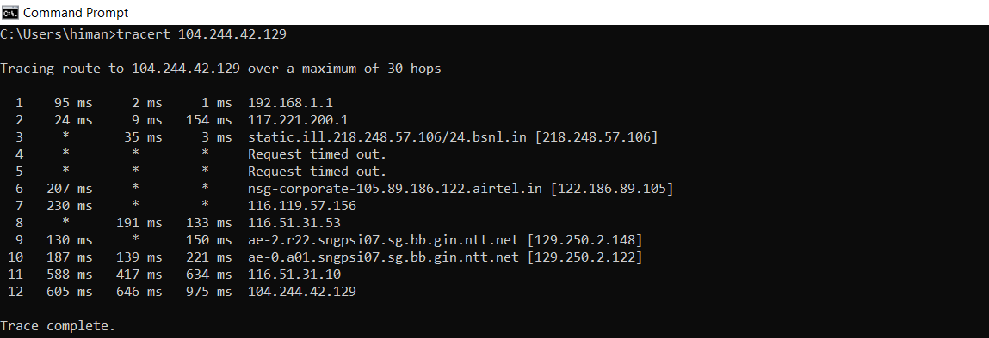

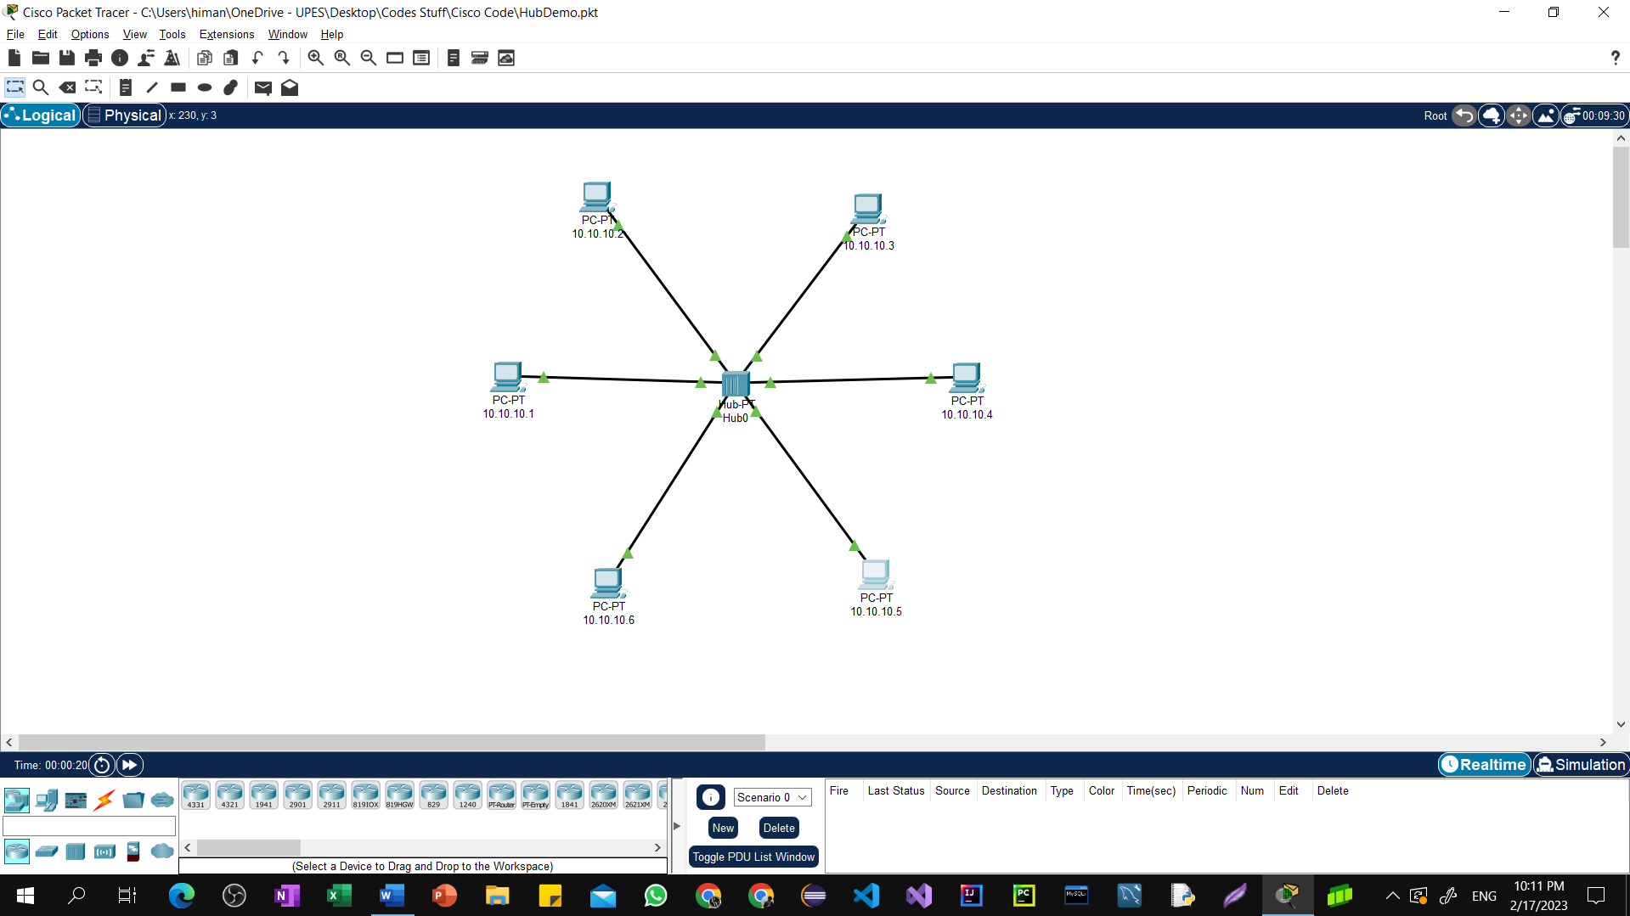**Basic Hub Setup in CPT**

**Basic Switch Setup in CPT**

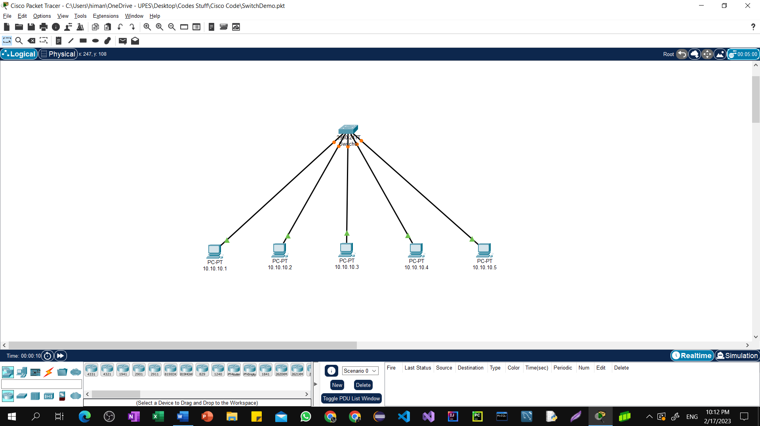

**Conclusion:**

Gain the knowledge about the network commands and network configure commands.